Chapter 19, Solution 75.

(a) We convert [z_{a}] and [z_{b}] to T-parameters. For N_{a}, 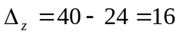.

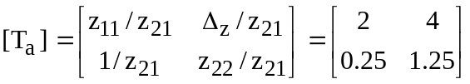

For N_{b}, 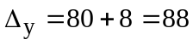.

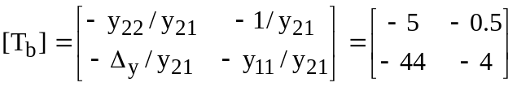

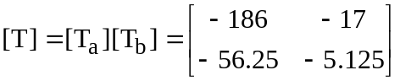

We convert this to y-parameters. 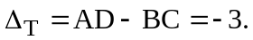

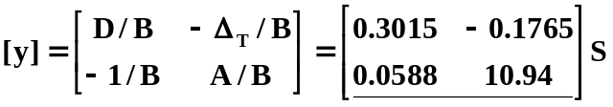

- The equivalent z-parameters are

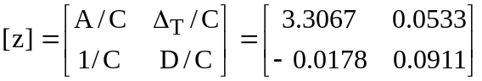

Consider the equivalent circuit below.

I₁ z₁₁ z₂₂ I₂

+ + +
+ Z_{L}
V_{i} z₁₂ I₂ z₂₁ I₁ V_{o}
- - -
-

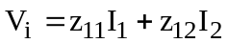 (1)

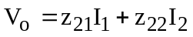 (2)

But 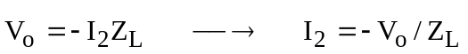 (3)

From (2) and (3) ,
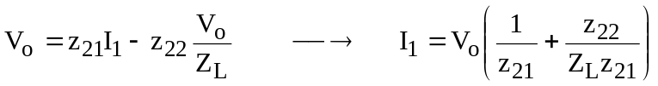 (4)

Substituting (3) and (4) into (1) gives

